[**DIGITAL SIGNAL & IMAGE PROCESSING LAB**](https://github.com/Amey-Thakur/DIGITAL-SIGNAL-AND-IMAGE-PROCESSING-AND-DIGITAL-SIGNAL-AND-IMAGE-PROCESSING-LAB)

[**EXPERIMENT - 2**](https://github.com/Amey-Thakur/DIGITAL-SIGNAL-AND-IMAGE-PROCESSING-LAB)

**PART B**

(PART B: TO BE COMPLETED BY STUDENTS)

***(Students must submit the soft copy as per the following segments within two hours of the practical. The soft copy must be uploaded on the Blackboard or emailed to the concerned lab in charge faculties at the end of the practical in case there is no Blackboard access available)***

| **Roll No. 50** | **Name: AMEY THAKUR** |
| --- | --- |
| **Class: COMPS-BE-B-50** | **Batch: B3** |
| **Date of Experiment: 30/07/2021** | **Date of Submission: 30/07/2021** |
| **Grade :** |  |

**A.1 Aim:**

[Write a program to perform Discrete Convolution such as Linear convolution and Circular convolution.](https://github.com/Amey-Thakur/DIGITAL-SIGNAL-AND-IMAGE-PROCESSING-AND-DIGITAL-SIGNAL-AND-IMAGE-PROCESSING-LAB)

**B.1 Snapshot of Convoled Signal:**

**(add a snapshot of output)**

1. **Linear Convolution**

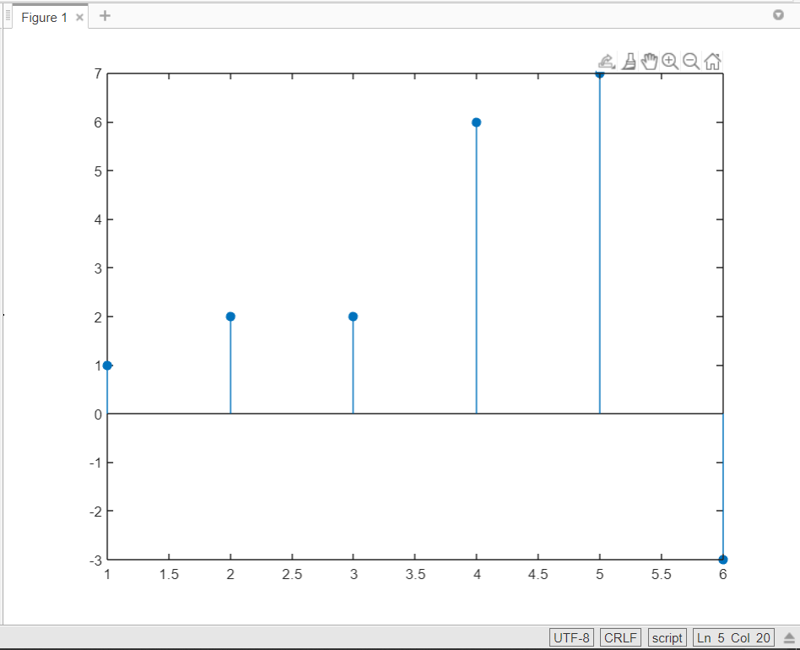

**Figure 1: Linear Convolution**

1. **Circular Convolution**

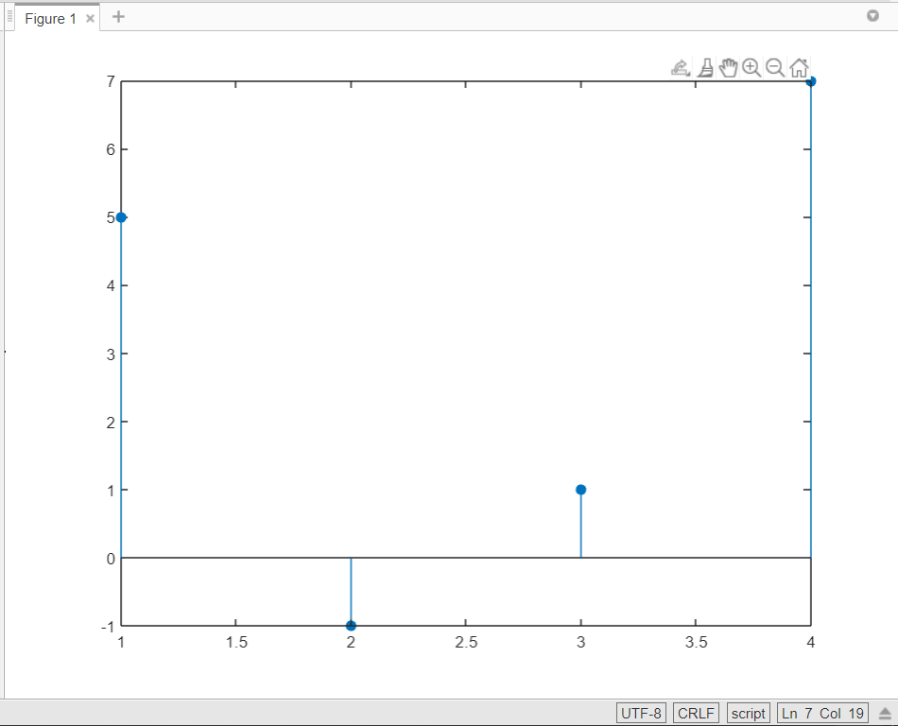

**Figure 2: Circular Convolution**

**B.2 Source code:**

**(Add source code)**

1. **Linear Convolution**

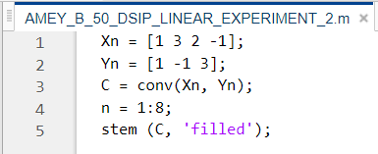

1. **Circular Convolution**

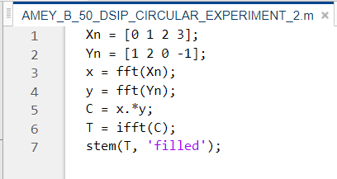

**B.3 Question of Curiosity:**

***(Write appropriate answers in your own word.)***

1. What are LTI systems?

Ans:

Linear time-invariant systems (LTI systems) are a class of systems used in signals and systems that are both linear and time-invariant. Linear systems are systems whose outputs for a linear combination of inputs are the same as a linear combination of individual responses to those inputs. Time-invariant systems are systems where the output does not depend on when input was applied. These properties make LTI systems easy to represent and understand graphically.

LTI systems are superior to simple state machines for representation because they have more memory. LTI systems, unlike state machines, have a memory of past states and can predict the future. LTI systems are used to predict long-term behaviour in a system. So, they are often used to model systems like power plants. Another important application of LTI systems is electrical circuits. These circuits, inductors, transistors, and resistors, are the basis upon which modern technology is built.

1. What is the use of linear convolution in DSP?

Ans:

Linear convolution is a mathematical operation done to calculate the output of any Linear-Time Invariant (LTI) system given its input and impulse response. It is applicable for both continuous and discrete-time signals.

We can represent Linear Convolution as: *y(n)=x(n)*h(n)*

Here, *y(n*) is the output (also known as convolution sum). *x(n)* is the input signal, and *h(n)* is the impulse response of the LTI system.

Both the sequences (input and impulse response) may or may not be of equal sizes in linear convolution. That is, they may or may not have the same number of samples. Thus the output, too, may or may not have the same number of samples as any of the inputs.

For example, consider the following signals:

*x(n): [1,2,3]*

*h(n): [1,2,3,4,5]*

As you can see, the number of samples in the input and Impulse response signals is not the same. Still, linear convolution is possible.

Here’s how you calculate the number of samples in the output of linear convolution.

*L = M + N – 1*

Where *M* is the number of samples in *x(n)*. *N* is the number of samples in *h(n)*. For the above example, the output will have *(3+5-1) = 7* samples.

1. What is circular convolution?

Ans:

Just like linear convolution, it involves the operation of folding a sequence, shifting it, multiplying it with another sequence, and summing the resulting products. However, in circular convolution, the signals are all periodic. Thus the shifting can be thought of as actually being a rotation. Since the values keep repeating because of the periodicity. Hence, it is known as circular convolution.

Circular convolution is also applicable for both continuous and discrete-time signals We can represent Circular Convolution as

*y(n)=x(n)⊕h(n)*

Here *y(n)* is a periodic output, *x(n)* is a periodic input, and *h(n)* is the periodic impulse response of the LTI system.

In circular convolution, both the sequences (input and impulse response) must be of equal sizes. They must have the same number of samples. Thus the output of a circular convolution has the same number of samples as the two inputs.

For the given example, circular convolution is possible only after modifying the signals via a method known as zero paddings. In zero padding, zeroes are appended to the sequence that has a lesser size to make the sizes of the two sequences equal. Thus, for the given sequence, after zero-padding:

*x(n) = [1,2,3,0,0]*

Now both *x(n)* and *h(n)* have the same lengths. So circular convolution can take place. And the output of the circular convolution will have the same number of samples. i.e., *5*.

**B.4 Conclusion:**

**(Write an appropriate conclusion.)**

As a result, we were able to effectively construct and comprehend the principles of Discrete Convolutions, such as Linear and Circular Convolutions, using MATLAB.